**iOG Solutions Profile**

iOG Solutions stands for intelligent O&G solutions. iOG Solutions is an Independent and reputed provider of consulting and implementation services for advanced and Intelligent Software solutions in Oil & Gas industry. It was founded in 2013 and is based out of Pune, India and Abu Dubai, U.A.E.

* iOG Solutions is an independent and reputed provider of consulting and implementation services on advanced MES, SCM, APC, Simulation and Modeling solutions for Oil & Gas industry.
* Our team of consultants has strong domain knowledge in upstream and downstream O & G industry and all leading software solutions.
* iOG focus on advanced software solutions and provide expert services for Upstream vertical in the area of
  + Geological & Geophysical
  + Reservoir Management
  + Well & Drilling
  + Production Management
  + Data Management
* Skilled & self-driven iOG consultants with Strong O&G domain knowledge
* Extensive experience in delivering advanced software solutions
* Executed 15+ projects in last two years in Europe, Middle East, India and SE Asia
* Resulted oriented working philosophy with focus on decisions and practical actions tailored to suit our clients’ unique requirement
* Strong capabilities to sustain success by engaging and building momentum at various levels of the client’s organization

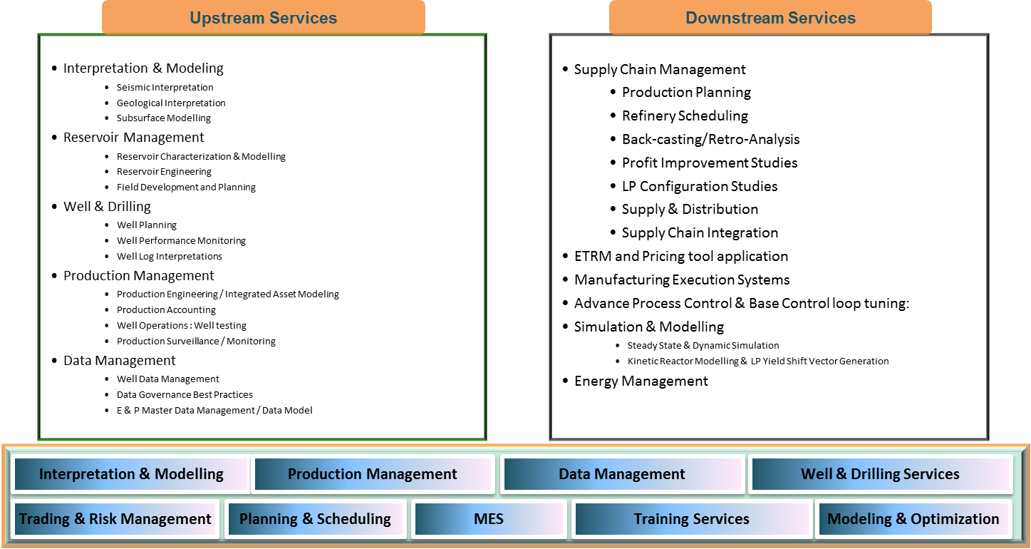

**Upstream Oil and Gas Industry Services**

The upstream segment of Oil & Gas industry, also known as the exploration and production (E&P), encompasses activities related to prospecting for oil and gas fields, drilling of exploratory and appraisal wells, analysis of these wells for production and economic viability, and the operation of viable wells to bring crude oil and raw natural gas to the surface. For a typical oil field, there are five stages in the Exploration and Production ‘life cycle’: Exploration, Appraisal, Development, Production and Decommissioning.

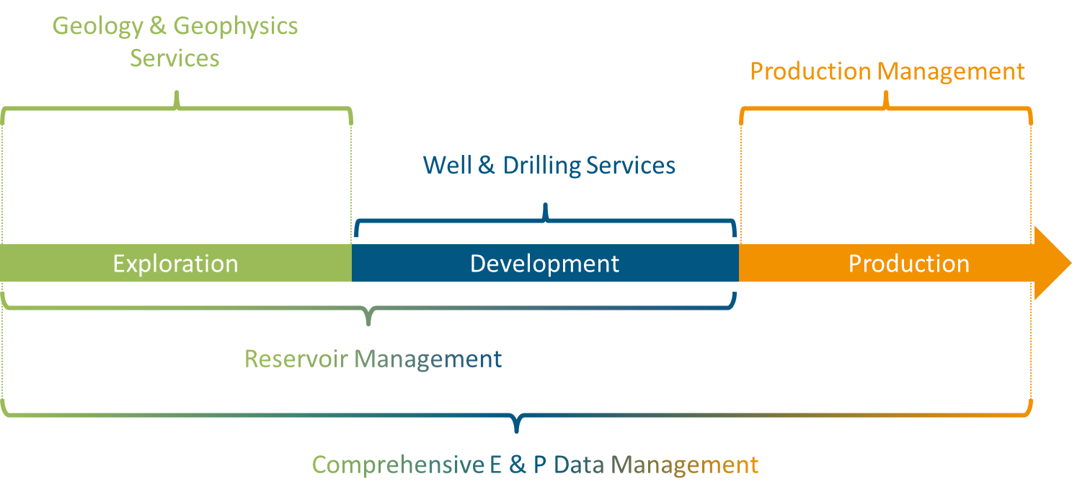

Each of these stages involves amalgamation of a wide variety of technical expertise and domain-specific activities and iOG Solutions strives to provide the world class services to its clients in their search for economic hydrocarbons.

iOG Solutions provides best in class expertise, solution and work flow for all the disciplines throughout the E&P Life cycle. Here are five of our Service Domains:

**Geology and Geophysics – Looking beyond the Surface**

Exploration is focused on understanding subsurface, discovering and targeting hydrocarbon rich zones. We help our clients in planning a broad range of G&G surveys for acquiring specific information to map the subsurface’ s complexities, interpret the retrieved Geological, Geophysical and Petrophysical data and generate a holistic 3D subsurface model (Earth Model). This enable clients in pinpointing the most accessible and economic hydrocarbon ‘traps’ thus giving a direction for planning further activities in accessing and exploiting these hydrocarbon sources.

**Reservoir: Tapping into the depths**

Oil and gas reservoir is the subsurface pool with hydrocarbons stored in the pores within porous or fractured rock formations.  iOG Solutions help in characterizing all substantial reservoir aspects, predict and study dynamic flow of fluids and gaining deeper insights into reservoir structure, estimate and extractable hydrocarbon reserves. This enables clients in selecting and designing the best recovery methods including water flooding, hydraulic fracturing and other EOR processes and then evaluates multiple field options for field development.

**Well and Drilling Services: Building Doorways**

Well & Drilling accounts for the major part of upstream operational economics. To address the uncertainty in the G & G, exploratory and appraisal well are drilled to ascertain the prospect’s viability and economics. The upstream segment essentially revolves around wells: from their locations, depths, sizes & numbers, construction and completion, operation, monitoring and workovers; to their eventual decommissioning. iOG’s Well and Drilling team guide it’s clients through all the well related activities with a wide range of advanced services like Well Modeling, Logging, Performance Monitoring & Analysis, Integrity assessment and Management Systems. Our Experts work closely with client and drilling contractor to design, plan, monitor and guide drilling operations and also, provide support for setting up a robust data management system for managing the vast stream of associated data.

**Production Management Services: Extracting value**

iOG Solutions offers its clients the complete range of Production Management services. These include design completion and surface systems management, selection and design of the artificial lift, design and implementation of production allocation and accounting systems, monitoring production volumes and other parameters in real-time, calculating and reporting KPIs, optimization of oil/gas production rates as well as in predicting future performance. It also includes diagnosis of productivity problems and evaluation of stimulation treatments.

**E & P Data Management: From Database Structuring to Analyses**

Upstream activities are highly data intensive and generate / require huge amounts of complex data that requires continuous monitoring and cleansing. Our team can help E & P enterprises in automating data acquisition and monitoring processes, cleansing and formatting of acquired data into Oil and Gas Industry standard Data Models.

Our experts can help integrate the incoming disparate data streams from multiple sources like Wells, Drilling, Logs, production, seismic, and surface facilities into a centralized repository, thus providing a single version of truth to the concerned departments. iOG Solutions can also, helps its clients make the most of their data, by making it easily interpretable using advanced BI, visualization and analytics.

# iOG Geological & Geophysical Services:

iOG understand subsurface and its complexity. It converts helps this subsurface complexity into simple understandable results through following services

iOG provides Interpretation & Modeling solutions in the following major areas:

**Geophysical Interpretation:** Geophysical Interpretation is the extraction of subsurface geologic information from the data obtained using various techniques of Geophysical data acquisition from subsurface or from wells, wth special emphsis of Seismic data. iOG Solutions can help its clients in making sense of seemingly obscure geophysical data parameters by interpreting them in terms of Subsurface characterisitics of the reservoir

* **Geological Interpretation:** iOG Solutions’ Geological Interpretation services aim at making an initial qualitative assessment of the subsurface from the publically available data sources; followed by design of comprehensive programs that focus on interpreting Geological history of the Basin, identification of different structural element, structure and geometries of the undergorund strata & Facies and Geomechanical Modeling
* **Petrophysical Analysis:** iOG Solutions Petrophysical analysis services enable our clients to interpret the petrophysical properties of subsurface formations from the data obtained through different logging, coring and imaging techniques, and eventually integrating this information into strucutral and sedimentary models. Our Petrophysical experts can help our clietns in building Petrophysical models, either Deterministic or Stochastic, that best suit their scenario and requirements, to gain an insight into the porperty distribution within the reservoir.
* **Subsurface Modeling:** Subsurface Modelling is the amalgamation of Geological, Geophysical and Petrophysical interpretation into a consistent and holistic model of the subsurface describing its different elements in detail. It incorporates the distribution of important reservoir properties like Porosity, permeability, Water Saturation, etc. into the geo-cellular grids, followed by conditioning to Facies models. Subsurface Modeling leads into Reservoir Characterization segment which we have described in more detail in a subsequent section.

# iOG Reservoir Management Services

iOG Solutions provides end-to-end consulting services for management of reservoirs, utilizing state-of-the-art geoscience and engineering technologies. Our extensive domain expertise encompasses reservoir behaviour & properties and fluid movement in a dynamic environment with respect to fluid contact, temperature, pressure and saturation. Through this, customers are able to understand the reservoir extent, fluid flow via porous & permeable media and to arrive at estimates indicating the life of the Reservoir.

Following are some of the reservoir management services we provide to our upstream clients

* **Static Reservoir modeling (Characterization):** It is the description and determination of reservoir architecture and quality with respect to distribution of porosity, permeability and rock properties. Our
  + - Build Reservoir Model: 3D Structural, Sedimentary & Petrophysical Model
    - Allocate Petrophysical Properties to each grid
    - Create Facies model and study geological connectivity of rock units
    - Enable Upscaling
* **Dynamic Reservoir Modeling (Simulation):** Enables our clients in predicting the flow of fluids via Porous & Permeable Zones for conventional and non-conventiona reservoirs. Our services Include;
  + - Solving static Numerical models using numerical techniques
    - Simulating the flow characteirstics of reservoir fluids and predicting dynamic behavior of the reservoir under different conditions
    - Forecasting future performance of the reservoirs and selecting the plans to maximize the production.
    - Hstory Matching to iteratively update the model parameters based on actual pressure and production.
* **Reservoir Engineering:** iOG Solutions’ Reservoir Engineering services help clients in determination of the size of available and extractable reserves and Production rates; followed by identification and planning of the best recovery methods to maximize their recovery, number and specification of wells, well potentials and capacity of the surface facilities.
* **Field Development Planning: For** evaluating multiple development options for a field and selecting the best option based on assessing trade-offs among multiple factors. It gives you the best technical solutions for field optimization.

# iOG Well & Drilling Services

iOG Well & Drilling services have evolved through vast experience on Well Planning, Designing and Optimization of Drilling Activities. We have capability of tracking, monitoring and advising on real time drilling support. We analyse drilling problems and let our customers know in hand before starting the actual drilling operation and hence our pre analytical skills help in reducing operator’s cost on Drilling Operations.

Our Services are as below:

* **Well Planning & Engineering:** iOG Well planning and drilling services include planning of well trajectory, selection of drilling hardware, planning of casing points, logging objectives, selection of logging tools, Test program & design criteria for testing, completion program and criteria for completion, which are needed from the time of identification of a subsurface target for a well (exploration, appraisal, or development well) until the completion of that well.
* **Well Drilling:** Drilling Experts at iOG Solutions can provide able services for Drilling Design & Program, Drilling Simulation, Geosteering, Drilling Monitoring and Drilling Data Management
* **Well Modeling:** iOG Solutions provides modeling support for multiphase flow inside and near wellbore to determine optimized Well Parameters. Well modeling can be applied to designing, optimizing and troubleshooting individual wells.
* **Well Performance Monitoring:** Well performance monitoring helps to identify wells where deliverability has deteriorated compared to its initial performance (IPR). Monitoring of pressure, temperature, flow, fluid density, vibration, acoustic and wellbore stress data enables understanding of well behavior while minimizing your operational HSE risks and overhead costs.
* **Well Integrity:** Well Integrity Management Systems aim at keeping the well health intact by monitoring well conditions which can cause well hazards and proactively taking corrective measures to prevent any problems. iOG Solutions provides Well Integrity management Systems and Gap Analysis are used to take care of your Well Integrity related issues.
* **Well Log Interpretation:** Well logs provide insight into the formations and conditions in the subsurface, aimed primarily at detection and evaluation of possibly productive horizons. Well Log Correlation is then used to co-relate the data and uses it for interpreting and predicting properties of other wells. Production Logging includes cement monitoring, corrosion monitoring, monitoring of formation fluid contacts (and saturations), perforation, plug and packer setting.
* **Well Data Management:** To manage well data from request-to-drill through abandonment.

# iOG Production Management Services

iOG Solutions offer its clients the complete range of Production Management services including design completion and management of surface systems, selection and design of artificial lift, design and implementation of production allocation and accounting system, real-time production monitoring, calculation and reporting of KPI’s, optimization of oil/gas production rates as well as predicting future performance. It also includes diagnosis of productivity problems and evaluation of stimulation treatment.

Our Production Management services can be broadly divided into following categories:

* **Production Engineering:** Production Engineering Services include design and selection of production facilities and equipment, selection and design of artificial lift, planning and design of Flow Assurance studies, development of field models and design of Well performance optimization programs.
* **Production Allocation & Accounting:** Production accounting helps you monitor business processes for production, transport, sales, and revenue of oil and gas. Our services include, Benchmarking of the production accounitng system, reacommendations for improvements and configuration and implementation of advanced modules and systems and validation of the resultant benefits.
* **Production Monitoring:** iOG Solutions supports its clients in selection and implementation of real time production monitoring systems and improvements in the current system, that can help them in maximizing oil recovery, extend life of well, while minimizing the operation costs. Our sevice include, identification of improved-production opportunities in underperforming wells or fields, identification of production and mechanical problems, Generating flow profiles to determine gas, oil, and water holdup, Monitoring changes in fluid saturation during production and Comparison with expected well performance
* **Production Optimization & Integrated Asset Management:** Production optimization aims at maximizing the total oil/gas production rates and minimizing operation costs. iOG Solutions provides Production Anaysis, and Well and Field optimization services based on Integrated Asset Modeling. It involves the conventional stages of Model characterization, Model calibration/Initialization and Predictions and Forecasting. Essentially, the models are built for each important component, tuned to mimic the actual production process and then used for Production optimization, scenario analysis and Production forecasting
* **Well Testing:** Well Tests serve as a tool for reservoir evaluation and characterization. It helps in defining reservoir limits (distances to boundaries, drainage area), estimate average drainage area pressure, characterize reservoir (permeability, skin factor, dual porosity or layered behaviour), diagnose productivity problems and evaluate stimulation treatment effectiveness (fracture conductivity, fracture half-length. Our Well testing services include, Designing and planning of different types of Well Tests as per requirement, multi-layered test analysis, well productivity analysis and forecasts, multi-well assessments to account for the Interference effects,

# iOG Data Management Services

iOG Solutions Data management Services include capturing, processing, loading, tracking, modifying, integrating, cleaning, rectificating errors, validating and visualizing data to best address our clients’ needs. We make the data valuable for our customers by organizing and presenting it in metrics that are key to their processes. We thus, help our clients in transforming raw data into information that can leading to deeper insights and better decision making.

Our service offerings include:

* **Seismic Data Management:** iOG Solutions’ Seismic Data services include loading of 2D/3D lines, seismic data conversion, formatting and migration using industry standard plug-in’s, process standardization, data workflow and quality assessment and analytics and visualization services.
* **Well Data Management:** iOG Solutions can help clients in managing well data from request-to-drill through abandonment. Our Data management team in collaboration with Well and Drilling experts enable clients to collect, store, modify, validate real time well and drilling data and give meaningful output to our customers through Visualization Tools, Dashboards and Key Performance Data (KPI) .
* **Real-time Production Data Management:** iOG Solutions enables it clients to track, acquire, consolidate and process real time production data from Data Historians and provides analytical, visualization & KPI support, with multiple well handling capacity, for timely identification of problems and immediate corrective decision making. Real-time production data management tools make it easier to manage production data and engineering workflows, utilizing standard practices and provide automatic responses to real time changes in data.
* **Data Quality Management:** iOG Solutions enables its clients to effectively manage their data quality through improved data capture and validation processes, Qulaity assessments, Data Aggregation, Normalization & Standardization for data coming from disparate sources,
* **Big Data:** Our real time Big data analytics enables clients to establish more efficient oil production, reduce costs and risks, improve safety, enhance regulatory compliance and improve overall decision making.
* **Data Governance:** iOG Solutions’ Data governance practice goes hand-in-hand with data quality efforts and master data management programs, and helps clients establish a good data governance structure, by ensuring proper data standardization & integration practices, tracking of data flows, establishing commonalities, such as rules, naming conventions, structures to improve the data management system.
* **Comprehensive E & P Master Data Management:** iOG Solutions can help clients insetting up of a single, trusted, central source, Master database associated with all E&P sources, leveraging industry standard solutions to optimize the entire hydrocarbon value chain.

# Our Solutions

iOG Solutions works with 4 arms in both the upstream and downstream domains. Implementation and consulting of advanced software technologies in the oil and gas domains are the core competencies of iOG solutions. So let us take a sneak peek at the 4 arms:

## iOGConsult

At iOG, we believe in creating intelligent environment, where we continuously learn & update ourselves with latest technologies & best practices in the world. We provide consulting services to improve our client’s process & bringing them up to best practices in the industry.

We renovate our client’s business using following business tools

* Business Process Mapping (As-Is, To-Be and Gap Analysis)
* Digital Oil Field Design Consulting Services
* PMC services
* Data Management methodology review
* Establishing Data Governance best practices

## iOGImplement

Experts in the different technology across Oil & Gas industries in our team can help you with implementation of these technologies. We specialize in implementing software solutions in the following areas and have experience on most of leading industry software solutions:

* + Implementation of Advanced Geological and Geophysical Interpretation
  + Implementation of Seismic Interpretation work-flows
  + Build an earth model
  + Implementation of Geo-cellular gridding techniques
  + Interpolation of Petrophysical properties
  + Subsurface Modeling workflows
  + Establishing Sensitivity Analysis scenarios
  + Implementation of 3D Structural, Stratigraphic, Sedimentary and Petrophysical Modeling tools
  + Integration of multi-disciplinary models

## iOGStudy

At iOG we undertake studies using latest technologies, tools & best practices for identification and quantification of profit improvement ideas in the following areas:

* Efficiency improvement studies with Simulation models
* Field Development and Planning
* Asset Development and Economic study
* Hydraulic design analysis
* Energy optimization studies
* Geology Data interpretation
* Well Planning
* Well Performance Monitoring report

## iOGTrain

Experts in our team dealing with technology areas across Oil & Gas industries can help you with training on these technologies at our office or at your site. We specialize in following technologies and offer standard & custom training programs for most of leading industry software solutions:

* Dynamic and Steady-state Simulation
* Field Development
* Production Optimization
* Production Accounting & reconciliation
* Well Modeling & Simulation